24-03-2024

Launch Linux EC2

Connect Linux EC2

Create a Custom user in Linux EC2

Create a Additional Volume in LInux EC2

Connect Linux machine from the windows EC2

( This Week Topic 30th and 31st March 2024 )

Backup strategy of EC2

SNapshots

AMI Backup

COnnect from Public Subnet EC2 to Private Subnet EC2

These all steps we have in last sessions

We are going to do the same for Linux EC2 Instance Via CLI ( Command Line interface which is black screen )

Install Mobexter( Have some colorful linux Machines ) ( Installation done )

This looks like this

Now go to your region

Click on lauch instance.

Select RED hat AMI  
Choose t2.micro as its free

Edit your network setting.

Use your custom VPC and public subnet   
Disable the public IP

Lets Assume I forgot to assign the public IP to be assigned .

Forgot to enable the public IP

And go to Elastic IP

Check Aavilbility zone of EC2 Instacne

Select AZ in Elastic IP

Now Click on allocate

Now Click on Associate Elastic IP to EC2 Instance

[65.1.104.160](https://ap-south-1.console.aws.amazon.com/ec2/home?region=ap-south-1#ElasticIpDetails:AllocationId=eipalloc-0d2a2090d058d4f38)

Don keep this Elastic IP free for long term it will charge you .

Check your EC2 Insatcne ID and private IP

And click on reassociation

and then click on Associate

Elastic IP associated to EC2 Instacne

Why Buy one get one ( we need to associate with EC2 )

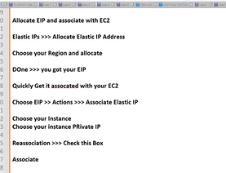

Now I can see the public IP

Elastic IP and Public IP both are coming from AWS open pool

One is permanent ( Public IP ) and one is non permanent( elastic IP ).

Login to the EC2 RED hat machine

Check user name

Use Mobaxterm to login to the Linux REDHAT Machine

Now click on OK EC2 instacne is logged in and password is taken by keypair.

User name and server name shown

Login to root user use the command sudo su

This user is not a (admin)root user , u need to login by sudo su command

Successful Login to EC2 Redhat Machine in Custom VPC

If we not enable the public IP

**Now Change the root user password for the EC2 Instance ( redhat )**

Go to Admin user by typing

Sudo su

Passwd ec2-user

Enter the new password India@123

Reenter the password India@123

By default EC2 instance asking for the keypair we need to disable the keypair .

You to modify sshd file

Type the command vi /etc/ssh/sshd.config

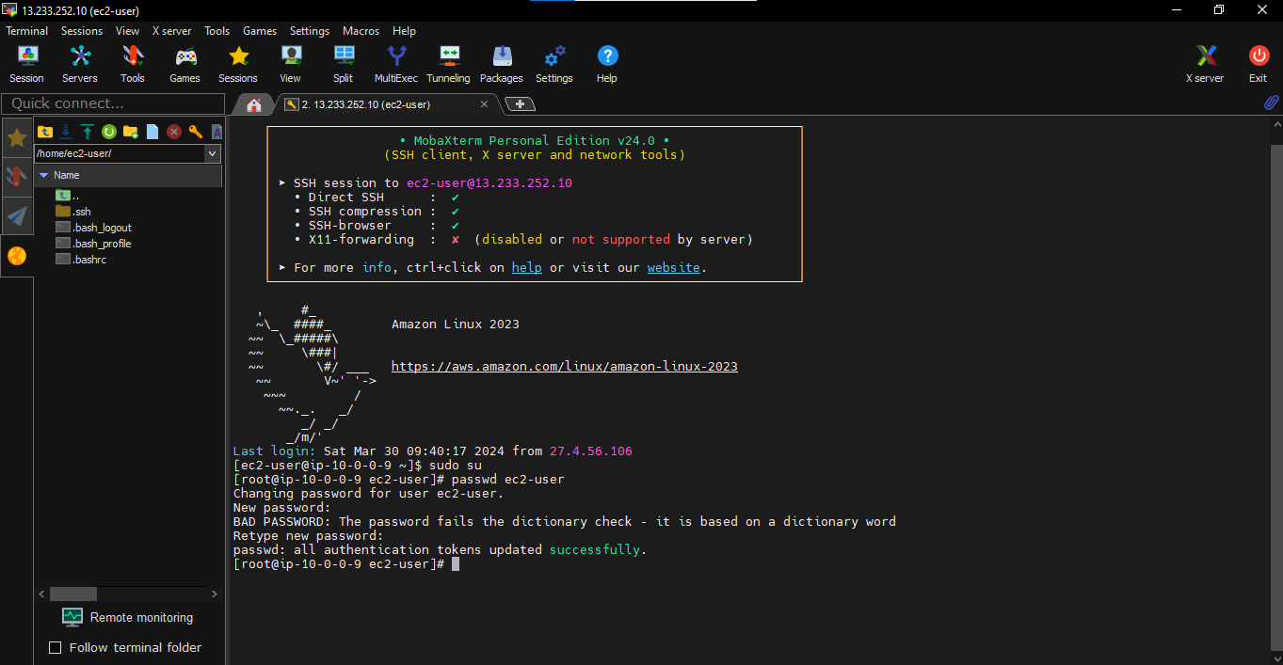

Run the command

Password authentication make yes to no and save the file ( Pres ESC + :wq!)

Service sshd restart

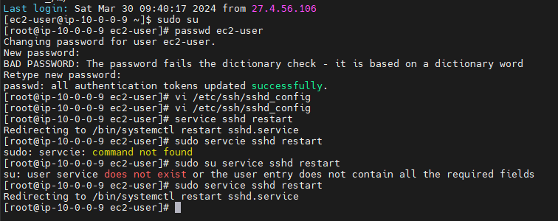

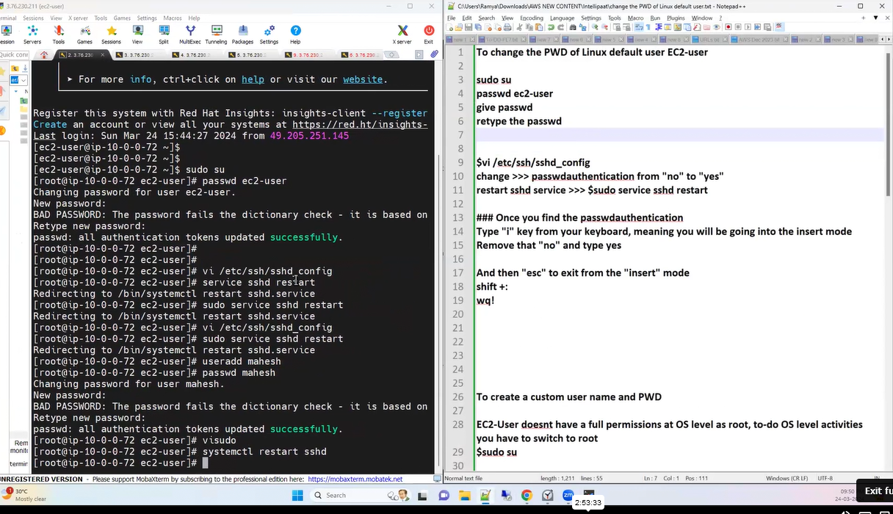

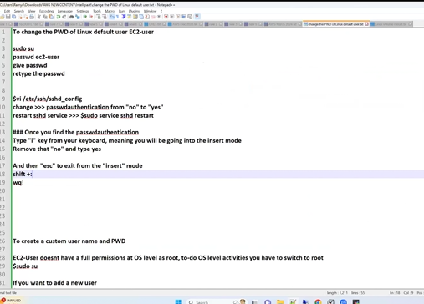

Without key I am able to access the server

My password Togglr@123

Now default password is changed ( private key removed )

Amazon AMI machine working fine .

Now run the command df -h to upgrade the volume

Go to the volume to add a volume

Change 100 Gib to 1 Gib.

Check EC2 Region

Attach volume

Run the command one more time

df -h

I want to list the block devices

## To check the disk space

df -h

## To list available block devices

lsblk

## To check if the newly attached volume is having any data

sudo file -s /dev/xvdb

This step is for only verification

If result says “/dev/xvdf: data“, it means your volume is empty.

Pls cross verify it xvdb

## To format the volume to the ext4 filesystem

sudo mkfs -t ext4 /dev/xvdb

OR (Either ext4 or xfs)***

## To format the volume to the xfs filesystem

## Create a directory and name it as you desire towards mounting your volume

sudo mkdir /myfirstvolume

## To mount the volume to above directory

sudo mount /dev/xvdb /myfirstvolume/

## To check the mounted volume

lsblk

This is successfully done

Type the command to check df -h

But if you restart your machine - this volume will be automatically unmount (detach)

To make it automount even after reboot, follow these steps

## Take the backup of the /etc/fstab file

sudo cp /etc/fstab /etc/fstab.bak

## To open /etc/fstab

vi /etc/fstab

## add below entry

/dev/xvdf /myfirstvolume ext4 defaults,nofail 0 0

##Actual Format ???

<device_name> <mount_point> <file_system_type> <fs_mntops> <fs_freq> <fs_passno>

## Final run to check if there are any errors

sudo mount -a

If no errors - you have successfully done

Restart your machine and cross verify

[ec2-user@ip-10-0-0-109 ~]$ history

1 df-h

2 df -h

3 clear

4 lsblk

5 sudo file -s /dev/xvdf

6 sudo file -s /dev/xvdb

7 sudo mkfs -t ext4 /dev/xvdb

8 sudo mkfs -t xfs /dev/xvdb

9 sudo mkdir /myfirstvolume

10 sudo mount /dev/xvdb /myfirstvolume/

11 lsblk

12 df -h

13 history

https://docs.aws.amazon.com/AWSEC2/latest/UserGuide/managing-users.html

https://www.chiark.greenend.org.uk/~sgtatham/putty/latest.html